**Model Development Phase Template**

|  |  |
| --- | --- |
| Date | 12 JULY 2024 |
| ID | 740022 |
| Project Title | Lymphography Classification Using ML |
| Maximum Marks | 4 Marks |

**Initial Model Training Code, Model Validation and Evaluation Report**

The initial model training code will be showcased in the future through a screenshot. The model validation and evaluation report will include classification reports, accuracy, and confusion matrices for multiple models, presented through respective screenshots.

**Initial Model Training Code:**

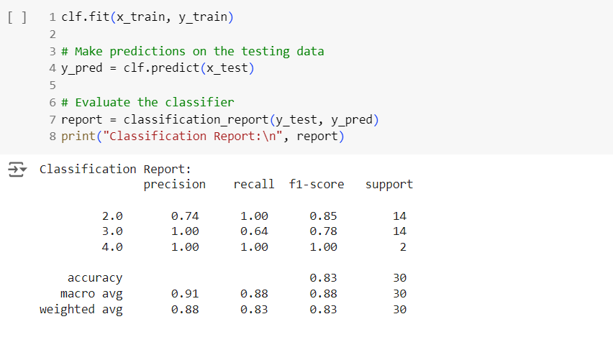

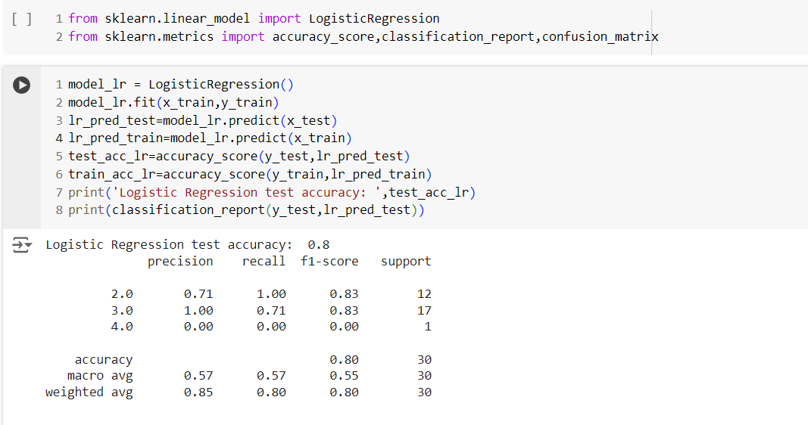

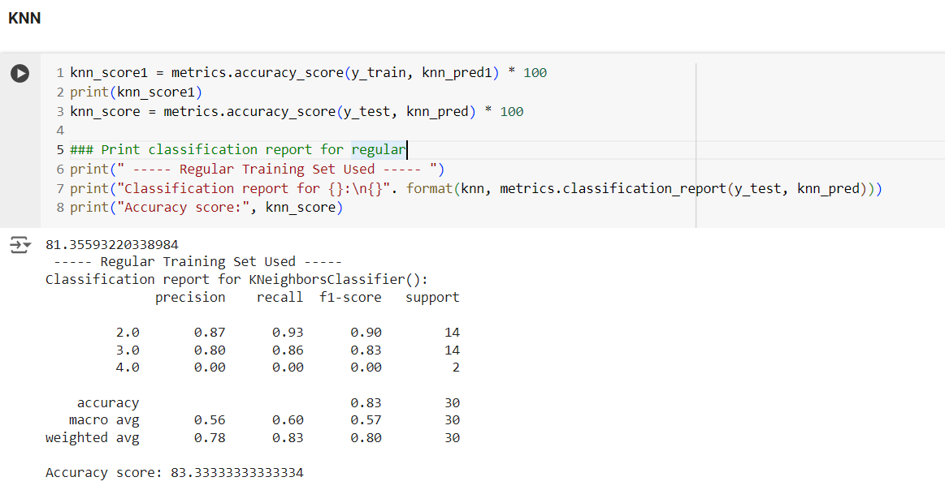

**Model Validation and Evaluation Report:**

|  |  |  |  |
| --- | --- | --- | --- |
| **Model** | **Classification Report** | **Accuracy** | **Confusion Matrix** |
| Decision tree classifier |  | 0.8 |  |
| Logistic Regression |  | 0.8 |  |
| K-Nearest Neighbors |  | 0.83 |  |
| Gradient Boosting |  | 0.83 |  |